Markov Decision Process (MDP)
Implementation, Execution & Output Report
All Python Modules – Source Code & Console Output

Table of Contents
1. Module 1 – Define MDP States, Actions, Transition Probabilities & Rewards
2. Module 2 – Transition Probability Matrices (NumPy)
3. Module 3 – Reward Table (Pandas Style Print)
4. Module 4 – Expected Reward Calculation
5. Module 5 – Output Summary Table (Pandas DataFrame)
6. Module 6 – MDP Activity Diagram Generation (Graphviz)
7. MDP Activity Diagram (Full Flowchart)

1. Module 1 – Define MDP States, Actions, Transition Probabilities & Rewards

Source Code
states = ["S1", "S2", "S3"]
actions = ["A1", "A2"]

num_states = len(states)
num_actions = len(actions)

transition_probabilities = {
("S1", "A1"): {"S2": 0.6, "S3": 0.2},
("S1", "A2"): {"S2": 0.4, "S3": 0.8},

("S2", "A1"): {"S1": 0.7, "S3": 0.5},
("S2", "A2"): {"S1": 0.3, "S3": 0.5},

("S3", "A1"): {"S1": 0.9, "S2": 0.4},
("S3", "A2"): {"S1": 0.1, "S2": 0.6}
}

rewards = {
("S1", "A1", "S2"): 5,
("S1", "A2", "S2"): 10,
("S1", "A1", "S3"): -1,
("S1", "A2", "S3"): -5,

("S2", "A1", "S1"): 3,
("S2", "A2", "S1"): 7,
("S2", "A1", "S3"): 2,
("S2", "A2", "S3"): 1,

("S3", "A1", "S1"): 4,
("S3", "A2", "S1"): 6,
("S3", "A1", "S2"): 0,
("S3", "A2", "S2"): -2
}

print("Number of States:", num_states)
print("States:", states)

print("\nNumber of Actions:", num_actions)
print("Actions:", actions)

print("\nTransition Probabilities")
for key, value in transition_probabilities.items():
state, action = key
print(f"{state}, {action} -> {value}")

print("\nRewards")
for key, value in rewards.items():
state, action, next_state = key
print(f"R({state}, {action}, {next_state}) = {value}")

Console Output
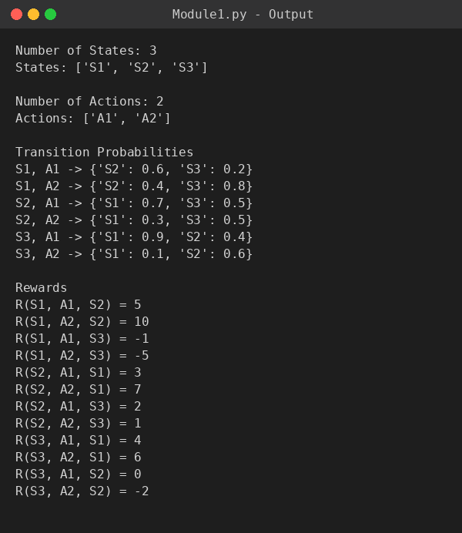

2. Module 2 – Transition Probability Matrices (NumPy)

Source Code
import numpy as np

states = ["S1", "S2", "S3"]

P_A1 = np.array([
[0.0, 0.6, 0.2],
[0.7, 0.0, 0.5],
[0.9, 0.4, 0.0]
])

P_A2 = np.array([
[0.0, 0.4, 0.8],
[0.3, 0.0, 0.5],
[0.1, 0.6, 0.0]
])

print("States:", states)

print("\nTransition Probability Matrix for Action A1")
print(P_A1)

print("\nTransition Probability Matrix for Action A2")
print(P_A2)

Console Output
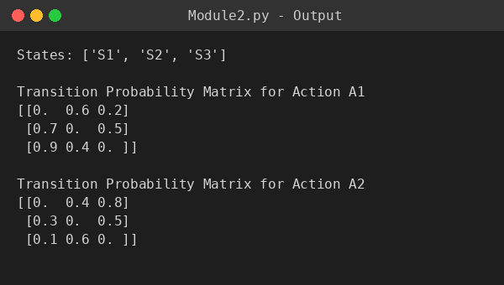

3. Module 3 – Reward Table (Pandas Style Print)

Source Code
import pandas as pd

reward_data = [
["S1", "A1", "S2", 5],
["S1", "A2", "S2", 10],
["S1", "A1", "S3", -1],
["S1", "A2", "S3", -5],
["S2", "A1", "S1", 3],
["S2", "A2", "S1", 7],
["S2", "A1", "S3", 2],
["S2", "A2", "S3", 1],
["S3", "A1", "S1", 4],
["S3", "A2", "S1", 6],
["S3", "A1", "S2", 0],
["S3", "A2", "S2", -2]
]

print("{:<15} {:<10} {:<12} {:<8}".format(
"Current State", "Action", "Next State", "Reward"))
print("-" * 50)

for row in reward_data:
print("{:<15} {:<10} {:<12} {:<8}".format(*row))

Console Output
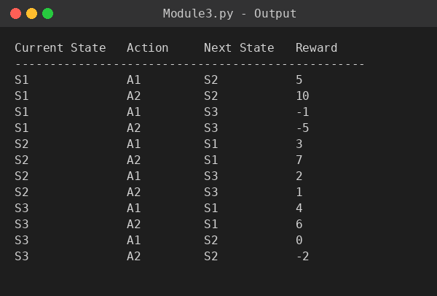

4. Module 4 – Expected Reward Calculation

Source Code
states = ["S1", "S2", "S3"]
actions = ["A1", "A2"]

transition_probabilities = {
("S1", "A1"): {"S2": 0.6, "S3": 0.2},
("S1", "A2"): {"S2": 0.4, "S3": 0.8},

("S2", "A1"): {"S1": 0.7, "S3": 0.5},
("S2", "A2"): {"S1": 0.3, "S3": 0.5},

("S3", "A1"): {"S1": 0.9, "S2": 0.4},
("S3", "A2"): {"S1": 0.1, "S2": 0.6}
}

rewards = {
("S1", "A1", "S2"): 5,
("S1", "A1", "S3"): -1,
("S1", "A2", "S2"): 10,
("S1", "A2", "S3"): -5,

("S2", "A1", "S1"): 3,
("S2", "A1", "S3"): 2,
("S2", "A2", "S1"): 7,
("S2", "A2", "S3"): 1,

("S3", "A1", "S1"): 4,
("S3", "A1", "S2"): 0,
("S3", "A2", "S1"): 6,
("S3", "A2", "S2"): -2
}

print("Expected Reward Calculation\n")

for state in states:
for action in actions:

print(f"State = {state}, Action = {action}")

expected_reward = 0

for next_state, probability in transition_probabilities[(state, action)].items():

reward = rewards[(state, action, next_state)]
value = probability * reward

print(f"P({next_state}|{state},{action}) × R({state},{action},{next_state})")
print(f"= {probability} × {reward} = {value}")

expected_reward += value

print(f"Expected Reward ({state}, {action}) = {expected_reward}")
print("-" * 50)

Console Output
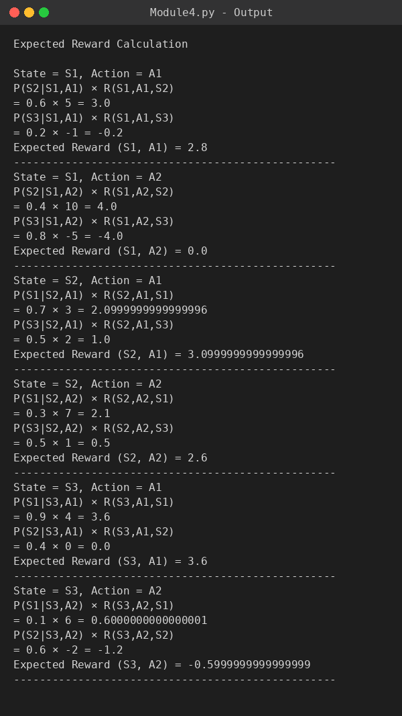

5. Module 5 – Output Summary Table (Pandas DataFrame)

Source Code
import pandas as pd

summary_data = [
["S1", "A1", 2.8],
["S1", "A2", 0.0],
["S2", "A1", 3.1],
["S2", "A2", 2.6],
["S3", "A1", 3.6],
["S3", "A2", -0.6]
]

summary_table = pd.DataFrame(
summary_data,
columns=["Current State", "Action", "Expected Reward"]
)

print("Output Summary Table\n")
print(summary_table)

Console Output
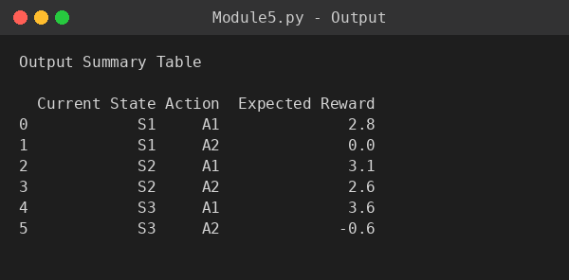

6. Module 6 – MDP Activity Diagram Generation (Graphviz)

Source Code
from graphviz import Digraph

activity = Digraph("MDP_Activity_Diagram", format="png")

# Top to Bottom Layout
activity.attr(rankdir="TB", bgcolor="white", splines="ortho", nodesep="0.6", ranksep="0.8")

# Default Node Style
activity.attr("node",
fontname="Arial",
fontsize="12",
style="filled",
color="black")

# -----------------------------
# Nodes
# -----------------------------

activity.node("Start",
"START",
shape="circle",
fillcolor="#90EE90")

activity.node("Init",
"Initialize\nMDP",
shape="box",
fillcolor="#87CEFA")

activity.node("State",
"Define\nStates\n(S1,S2,S3)",
shape="box",
fillcolor="#FFFACD")

activity.node("Action",
"Define\nActions\n(A1,A2)",
shape="box",
fillcolor="#FFFACD")

activity.node("TP",
"Store Transition\nProbabilities",
shape="box",
fillcolor="#D8BFD8")

activity.node("Reward",
"Store\nReward Matrix",
shape="box",
fillcolor="#F4A460")

activity.node("Display",
"Display States,\nActions,\nMatrices",
shape="box",
fillcolor="#AFEEEE")

activity.node("Decision",
"More\nStates?",
shape="diamond",
fillcolor="#FFD700")

activity.node("Current",
"Select\nCurrent State",
shape="box",
fillcolor="#E6E6FA")

activity.node("Choose",
"Choose\nAction",
shape="box",
fillcolor="#E6E6FA")

activity.node("Transition",
"Apply\nTransition\nProbability",
shape="box",
fillcolor="#98FB98")

activity.node("Next",
"Move to\nNext State",
shape="box",
fillcolor="#98FB98")

activity.node("RewardCalc",
"Receive\nReward",
shape="box",
fillcolor="#FFB6C1")

activity.node("Expected",
"Calculate\nExpected Reward",
shape="box",
fillcolor="#87CEEB")

activity.node("Summary",
"Generate\nSummary Table",
shape="box",
fillcolor="#FFA07A")

activity.node("Visual",
"Visualize\nGrid Environment\n& State Diagram",
shape="box",
fillcolor="#ADD8E6")

activity.node("End",
"END",
shape="doublecircle",
fillcolor="#90EE90")

# -----------------------------
# Connections
# -----------------------------

activity.edge("Start", "Init")
activity.edge("Init", "State")
activity.edge("State", "Action")
activity.edge("Action", "TP")
activity.edge("TP", "Reward")
activity.edge("Reward", "Display")
activity.edge("Display", "Decision")

activity.edge("Decision", "Current", label="Yes")
activity.edge("Current", "Choose")
activity.edge("Choose", "Transition")
activity.edge("Transition", "Next")
activity.edge("Next", "RewardCalc")
activity.edge("RewardCalc", "Expected")
activity.edge("Expected", "Decision")

activity.edge("Decision", "Summary", label="No")
activity.edge("Summary", "Visual")
activity.edge("Visual", "End")

# -----------------------------
# Generate Diagram
# -----------------------------

activity.render("MDP_Activity_Diagram", view=True)

print("Activity Diagram Generated Successfully!")

Console Output
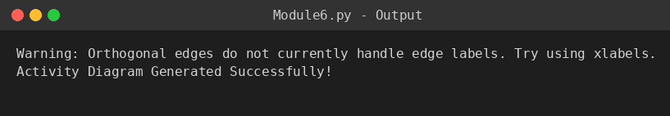

7. MDP Activity Diagram (Full Flowchart)
The diagram below was generated by Module 6 using Graphviz and represents the complete activity flow of the MDP program, from initialization through state/action definition, transition & reward storage, iterative processing, expected reward calculation, and final summary/visualization.
